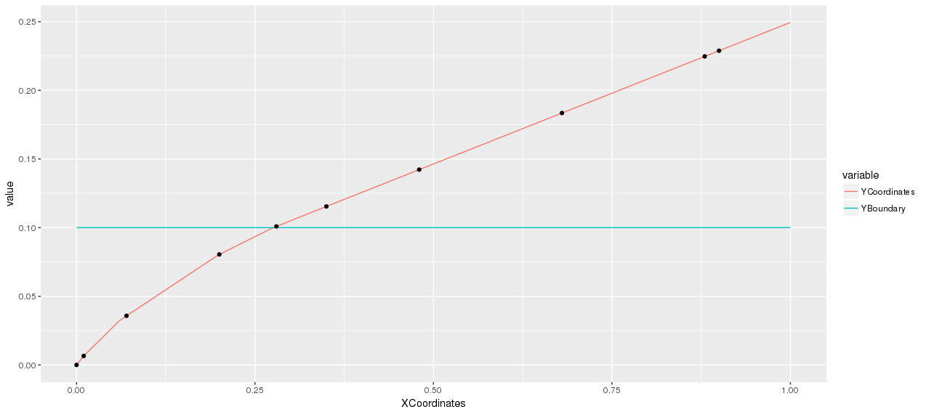
$PlansChangingPoints
[1] 0.00 0.01 0.07 0.20 0.28 0.35 0.48 0.68 0.88 0.90

$Plans
$Plans[[1]]
[,1] [,2] [,3] [,4]
[1,] 0 0 0 0
[2,] 0 0 0 0
[3,] 0 0 0 0
[4,] 0 0 0 0
[5,] 0 0 0 0

$Plans[[2]]
[,1] [,2] [,3] [,4]
[1,] 1 0 0 0
[2,] 0 0 0 0
[3,] 0 0 0 0
[4,] 0 0 0 0
[5,] 0 0 0 0

$Plans[[3]]
[,1] [,2] [,3] [,4]
[1,] 2 0 0 0
[2,] 1 0 0 0
[3,] 0 0 0 0
[4,] 0 0 0 0
[5,] 0 0 0 0

$Plans[[4]]
[,1] [,2] [,3] [,4]
[1,] 3 0 0 0
[2,] 2 0 0 0
[3,] 1 0 0 0
[4,] 0 0 0 0
[5,] 0 0 0 0

$Plans[[5]]
[,1] [,2] [,3] [,4]
[1,] 4 0 0 0
[2,] 3 0 0 0
[3,] 2 0 0 0
[4,] 1 0 0 0
[5,] 0 0 0 0

$Plans[[6]]
[,1] [,2] [,3] [,4]
[1,] 4 1 0 0
[2,] 3 0 0 0
[3,] 2 0 0 0
[4,] 1 0 0 0
[5,] 0 0 0 0

$Plans[[7]]
[,1] [,2] [,3] [,4]
[1,] 4 1 0 0
[2,] 3 0 0 0
[3,] 2 0 0 0
[4,] 1 1 0 0
[5,] 0 0 0 0

$Plans[[8]]
[,1] [,2] [,3] [,4]
[1,] 4 1 0 0
[2,] 3 0 0 0
[3,] 2 0 0 0
[4,] 1 1 1 0
[5,] 0 0 0 0

$Plans[[9]]
[,1] [,2] [,3] [,4]
[1,] 4 1 0 0
[2,] 3 0 0 0
[3,] 2 0 0 0
[4,] 1 1 1 1
[5,] 0 0 0 0

$Plans[[10]]
[,1] [,2] [,3] [,4]
[1,] 4 1 1 0
[2,] 3 0 0 0
[3,] 2 0 0 0
[4,] 1 1 1 1
[5,] 0 0 0 0
Raised Cosine distribution

